**A Level PE – Physical Education Confidence Summary**

Key words and definitions:



Self Confidence

Self Efficacy

Social Facilitation

Social Inhibition

Evaluation Apprehension

Home field advantage

Strategies to eliminate adverse effects

Theories:

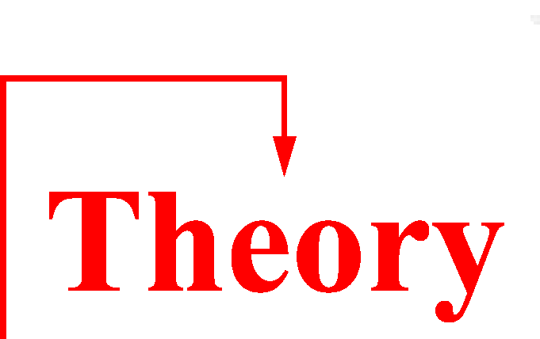

Bandura’s model (4 aspects)

Baron’s distraction conflict theory

Syllabus requirements:

