Aggression and confidence exam questions and answers

Macintosh HD:Users:sapurangill:Desktop:Screen Shot 2013-02-24 at 12.16.57.png

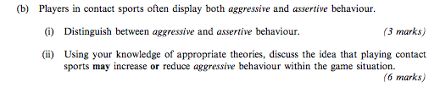

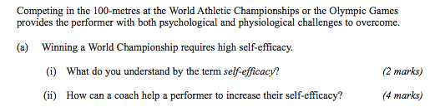

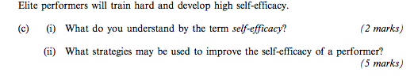

24 marks