Arousal examination questions

June 2006
4.

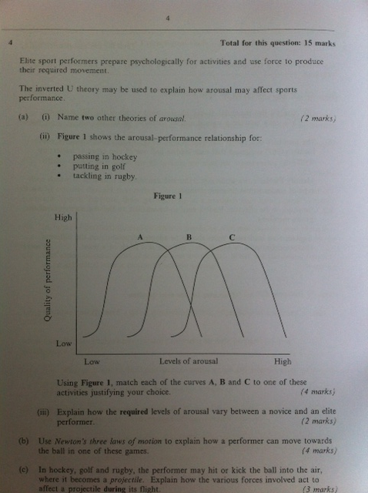

January 2009
1 d. Using drive theory, explain why performers such as golfers might hit some bad shots due to their levels of arousal. (3 marks)

