Badminton 2B.P4
SKILL / TECHNIQUE | Description of how to perform this skill
Low Serve

High Deep Serve

Drop Shot

Overhead Clear

Smash

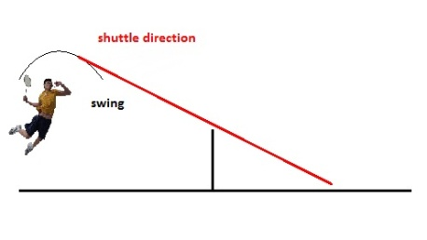

2B.P4: Describe the technical and tactical demands of two selected sports.
http://www.badmintonbible.com/articles/singles-tactics/

TACTIC | WHY IS IT USED/GOOD?
Movement pressure  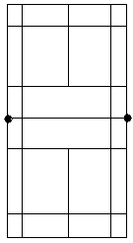 | What is it and why is it used?
Central base position | What is it and why is it used?
Hitting to the corners | What is it and why is it used?
Deception  ??? | What is it and why is it used?

