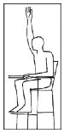

Line Judges – This is called when the shuttle lands outside of the court or the playing area. The judge must also shout ‘OUT’.

Line Judge – If the judge was unable to see what happened they do this.

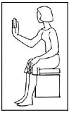

Misconduct – This is when somebody is aggressive or throws their racket down. The umpire can then give a yellow card to warn the player not to behave the same way.

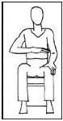

Service Judge – The whole of the shuttle is not completely below the waist when serving.

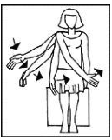

Line Judge – If the shuttle lands in the judge will point to the line with the right hand and say nothing.

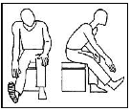

Service Judge – Serves must contact with the base of the shuttle. If not this will be called.

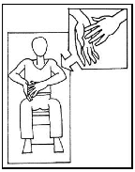

Service Judge – The whole of the shuttle was not below the waist when being hit.

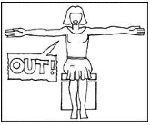

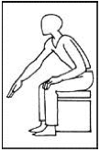

Service Judge – The racket must move in a forward direction after a serve. If it moves across the body it is a fault.

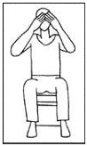

Service Judge – Serves must be taken in the box. If either foot is over the line the signal would be called.