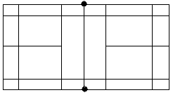
BADMINTON TACTICS

Shot: ....................... Shot: ...................... . Shot: ........................

Shot: ......................... Shot: .......................... Shot: .........................
Put an X on each court where the shuttle should land.
KEY
Opponent
You

