Leadership exam questions

Macintosh HD:Users:sapurangill:Desktop:Screen Shot 2013-02-24 at 12.39.02.png

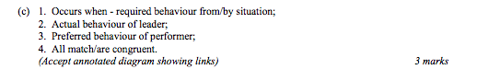

Macintosh HD:Users:sapurangill:Desktop:Screen Shot 2013-02-24 at 12.39.54.png

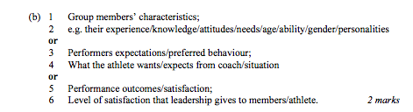

Macintosh HD:Users:sapurangill:Desktop:Screen Shot 2013-02-24 at 12.40.34.png

