1C.5 2C.P5 2C.M5 2C.D2
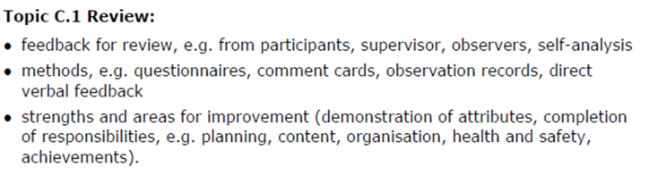
Planning and organisation
Strengths | Areas for improvements
Health and safety
Strengths | Areas for improvements
Attributes
Strengths | Areas for improvements
Qualities
Strengths | Areas for improvements
Responsibilities
Overall
Strengths | Areas for improvements

Use your review from above to set at least 3 SMARTER Targets. To achieve the merit you need to explain your target, to achieve the distinction you need to justify your targets for future development.
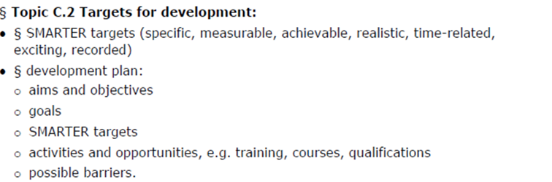

Target 1
Specific
Measurable
Achievable
Realistic
Timed
Exciting
Recorded

Target 2
Specific
Measurable
Achievable
Realistic
Timed
Exciting
Recorded

Target 3
Specific
Measurable
Achievable
Realistic
Timed
Exciting
Recorded

Personal Development Plan
Key action | Why I need to improve this area? | What will I actually do to achieve this and how will I know it has improved?

