Week 1 revision Examination questions

Personality and Arousal

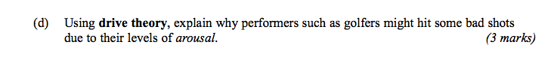

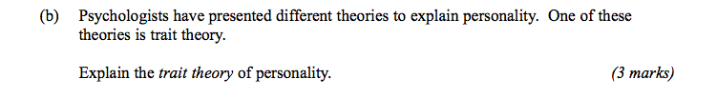

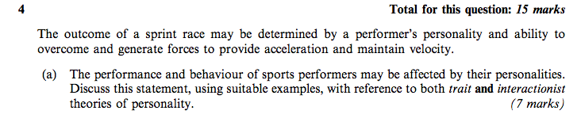

Total 16 marks

