Week 2 answers and questions

Attitudes and anxiety

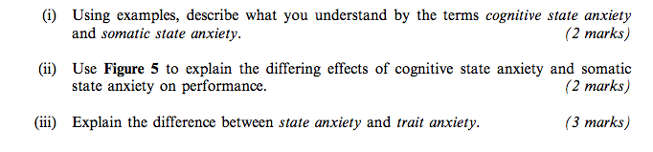

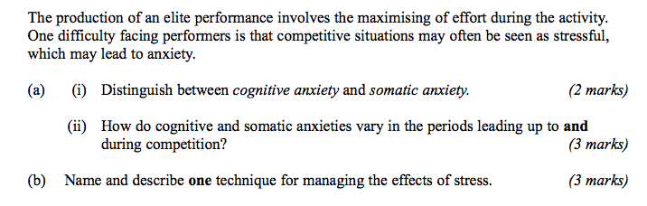

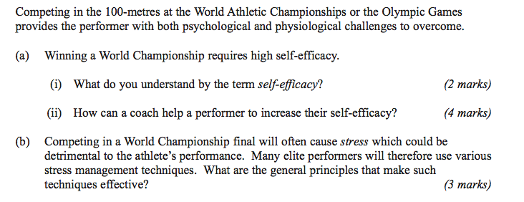

27 marks

